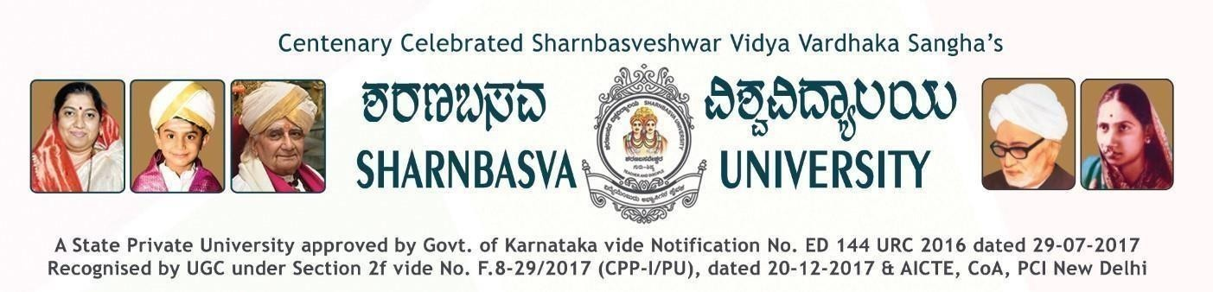

A

PROJECT REPORT ON
“Cyber Threat Detecting System using AI”

Submitted to
Computer Science and Engineering
Faculty of Engineering and Technology (Co-Education)

In partial fulfillment of the Eight Semester Project

Submitted By

ABHISHAKE USN: SG21CSE004

NISHA SHUKLA USN: SG21CSE081

SAINATH USN: SG21CSE119

SIRINA BEGUM USN: SG21CSE142
Under the guidance of

PROF. BASAWANTRAO PATIL

CERTIFICATE
This is to certify that the project work entitled “ Cyber Threat Detecting System Using AI ” is bonafide work carried out by ABHISHEK (SG21CSE004) , NISHA SHUKLA (SG21CSE081), SAINATH (SG21CSE119), SIRINA BEGUM (SG21CSE142) in partial fulfillment of B.Tech 8th Semester in Computer Science and Engineering of the Faculty of Engineering And Technology (Co-Education), SHARNBASVA UNIVERSITY, Kalaburagi. During the year 2024-2025. It is certified that, he/she has completed the project satisfactorily.

Marks Details

Sl No. | Name of the Student | USN | Maximum Marks | Marks Obtained
1 | ABHISHEK | SG21CSE004
2 | NISHA V SHUKLA | SG21CSE081
3 | SAINATH | SG21CSE119
4 | SIRINA BEGUM | SG21CSE142

Guide Chairman Dean

Name of the Examiners Signature with Date 1.
2.

ACKNOWLEDGEMENT

Any achievement does not depend solely on the individual efforts but also on the guidance, encouragement and co-operation of intellectual, elders and friends. A number of personalities, in their own capacities have helped us in carrying out his friends. A number of personalities, in their own capacities have helped us in carrying out this seminar work. I would like to take this opportunity to thank them all.

First of all, I would like to express our immense gratitude to Dr. SANNABASANAGOU DADOLLEGOUDAR, Registrar, Sharnbasva University, Kalaburagi for his help and inspiration during the tenure of the course.

I would like to express our immense gratitude to Dr. SHIVAKUMAR JAWALIGI, Dean, Sharnbasva University, Kalaburagi for his help and inspiration during the tenure of the course.

I also extend my sincere thanks to Dr. SHIVAKUMAR KAGI, Chairman, Department of Computer science engineering Faculty of Engineering & Technology (Co-Ed), Sharnbasva University, Kalaburagi for his constant encouragement.

I express my deep sense of gratitude to Prof. BASWANTRAO PATIL, as a guide for his valuable suggestions and encouragement. He is the one who provided me a dynamic intellectual and stimulating state of mind to work hard.
I also extend my sense of gratitude and sincere thanks to all the faculty members of Computer science engineering department, Sharnbasva University (Co-Ed), for their constant encouragement and support.

ABHISHEK (USN: SG21CSE004) NISHA V SHUKLA (USN: SG21CSE081) SAINATH (USN: SG21CSE119)
SIRINA BEGUM (USN: SG21CSE142)

ABSTRACT

The increasing sophistication of cyber threats poses serious risks to organizations, governments, and individuals. Traditional rule-based intrusion detection systems often fail to detect novel or evolving attacks. This project presents an AI-based cyber threat detection system that leverages machine learning to classify malicious network traffic. Using Wireshark, raw packet data was captured and preprocessed into structured features. A Random Forest model was trained to distinguish between normal and suspicious traffic patterns. The system achieved high accuracy in detecting anomalies, demonstrating the effectiveness of ensemble learning for cybersecurity. Future improvements may include real-time deployment and integration with deep learning models for enhanced detection.
Keywords: Cybersecurity, Intrusion Detection, Random Forest, Wireshark, Machine Learning, AI.

TABLE OF CONTENTS

Abstract |  | i
Table of Contents |  | ii
List of Figures |  | iii
List of Tables |  | iii
Acknowledgement |  | iv
Chapter  No. | Chapter Title | Page No.
1 | Introduction | 01
2 | Literature Survey | 07
3 | Proposed Methodology | 12
4 | Objectives | 22
5 | Methodology | 26
6 | Outcomes | 34
7 | Results and Discussions | 36
8 | Conclusion | 41

